AI Assisted Coding
Lab Assignment 4.3
Name : Syed Mashood Adnaan
2303A54059
Batch 47_B

Task 1: Zero-Shot Prompting – Leap Year Check

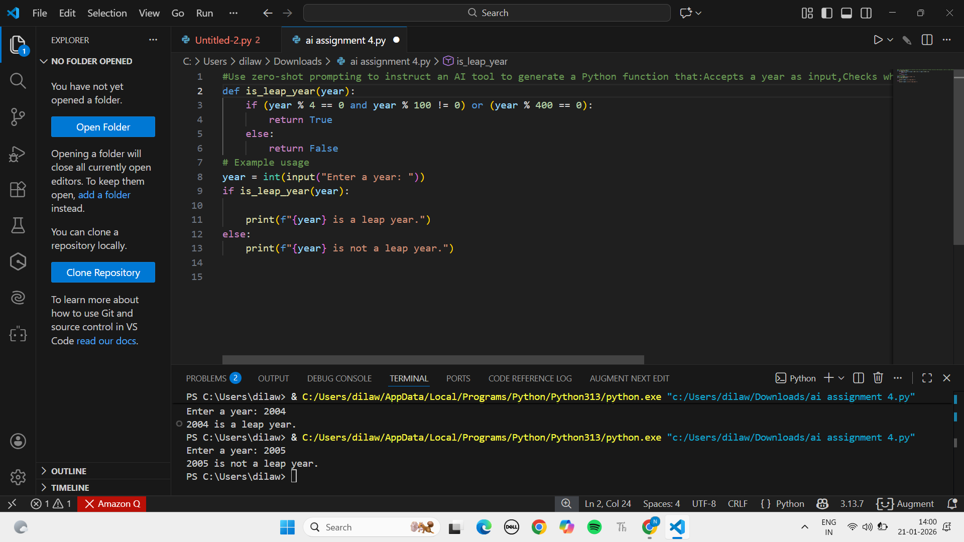
A year is considered a leap year based on the following rules:
- If a year is divisible by 4, it is generally a leap year.
- However, if the year is divisible by 100, it is not a leap year.
- An exception to this rule is when the year is also divisible by 400—in that case, it is a leap year.
Examples:
- 2004 → Leap year (divisible by 4)
- 2005 → Not a leap year (not divisible by 4)
Task 2: One-Shot Prompting – Centimeters to Inches Conversion
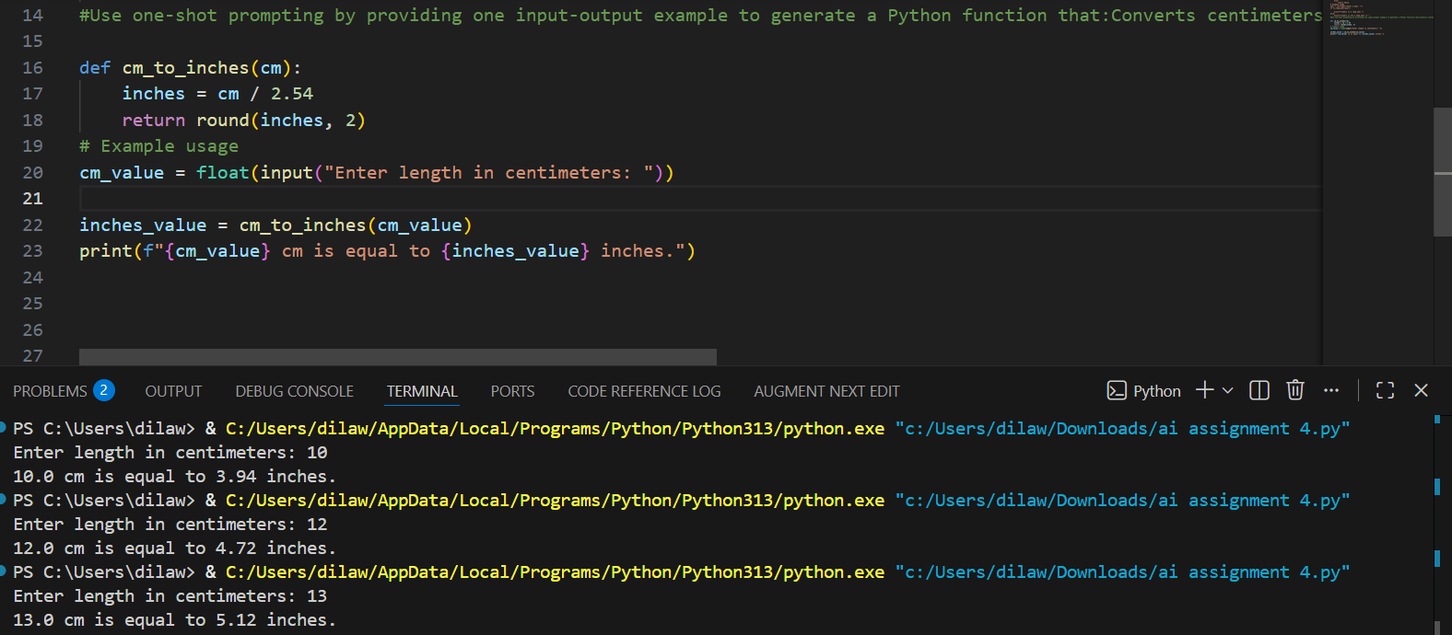
Explanation:
To convert a length from cm to inches, you divide the length in cm by 2.54.
- To convert 10 centimeters to inches, you would calculate 10 cm / 2.54, which equals approximately 3.94 inches.
Task 3: Few-Shot Prompting – Name Formatting
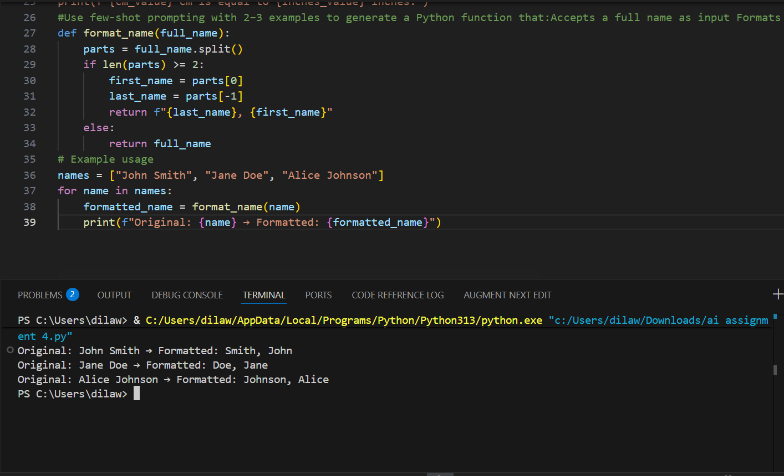
Explanation:
Split():- breaks the name into words
If there are 2 words it takes as “last”,”first” and rearranges otherwise it shows error.
Task 4: Comparative Analysis – Zero-Shot vs Few-Shot

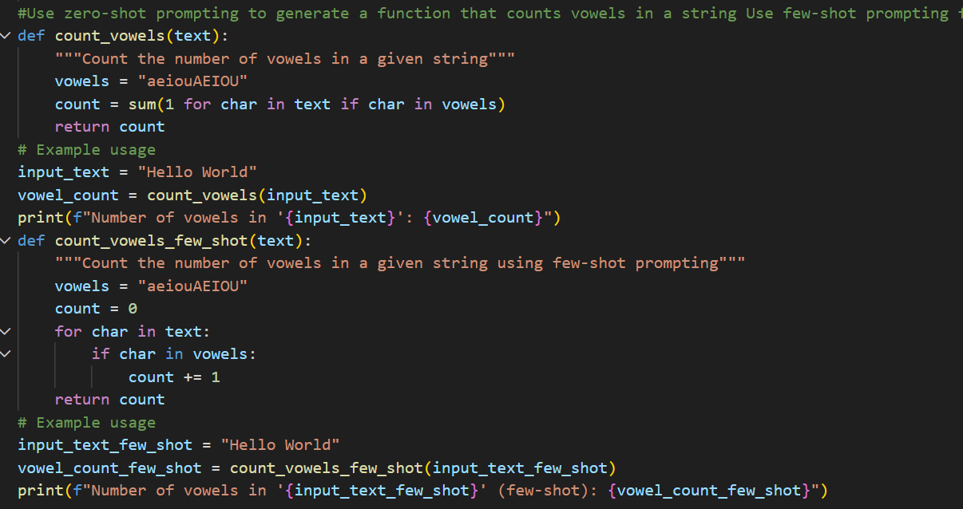
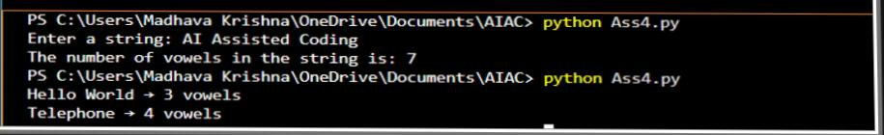
Explanation:
For zero-shot prompting:- It checks each character in the string, if it is vowel it adds 1 to the count.
For Few-shot prompting:- It goes letter by letter using for loop and increase count by 1 if letter is vowel. After the loop return the count.

Task 5: Few-Shot Prompting – File Handling

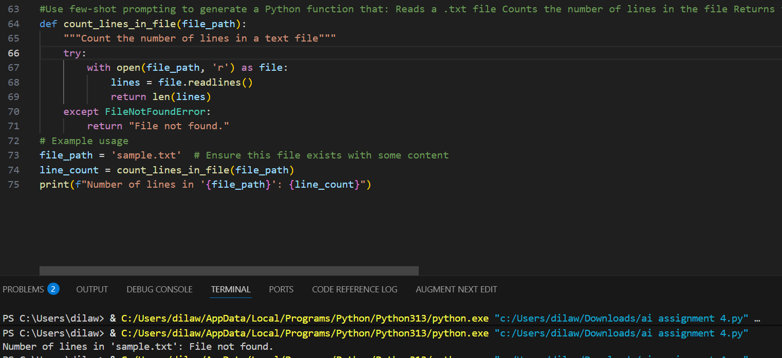
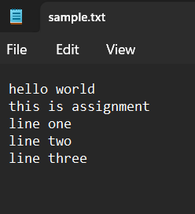
AI-assisted logic explanation:-
To count the number of lines in a .txt file, you can open the file in read mode and use the readlines() method to read all lines into a list.
Then, you can use the len() function to get the number of lines by calculating the length of the list.
Make sure to handle the case where the file might not exist by using a try-except block to catch a FileNotFound Error.

